EXPERIMENT 19
IMPLEMENTATION OF SPECTRAL SUBTRACTION FOR SPEECH NOISE REDUCTION USING MATLAB
Name: Lokesh A
Register Number: 192512293
Programme: B.E. Electronics and Communication Engineering (ECE)
Date of Experiment: 13 October 2026

1. AIM
To implement spectral subtraction in MATLAB to reduce additive white Gaussian noise from a test speech-like signal, compare clean, noisy and enhanced waveforms, and evaluate performance using signal-to-noise ratio (SNR).

2. SOFTWARE REQUIRED
MATLAB with FFT, inverse FFT, Hamming-window generation, and plotting functions.

3. THEORY
Spectral subtraction is a frequency-domain noise-reduction technique. A noisy signal is divided into short overlapping frames. Each frame is windowed and transformed using the Fast Fourier Transform (FFT). An estimate of the noise magnitude spectrum is subtracted from the noisy magnitude spectrum. The noisy phase is retained, and the inverse FFT converts the processed spectrum back into the time domain.
Ŝ(k) = max { |Y(k)| − αN̂(k), β|Y(k)| }
Here, |Y(k)| is the noisy-frame magnitude spectrum, N̂(k) is the estimated noise magnitude spectrum, α is the over-subtraction factor, and β is the spectral-floor factor. The spectral floor avoids forcing all estimated magnitudes to zero. Overlap-add combines processed frames, and window-gain normalization compensates for overlapping windows.

4. ALGORITHM
- Generate a three-tone test signal with a smooth amplitude envelope.
- Add white Gaussian noise at a target SNR of 10 dB.
- Divide the noisy signal into 20 ms frames with a 10 ms frame shift.
- Apply a Hamming window and compute the FFT of each frame.
- Estimate the average noise magnitude spectrum from the initial frames.
- Subtract the scaled noise spectrum and apply a spectral floor.
- Preserve phase, perform the inverse FFT, and reconstruct using overlap-add.
- Calculate input/output SNR and plot the signals and their spectra.

5. MATLAB PROGRAM
clc; clear; close all;

%% EXPERIMENT 19: SPECTRAL SUBTRACTION FOR SPEECH NOISE REDUCTION
%% 1. SIGNAL PREPARATION
Fs = 16000;
duration = 1.5;
t = 0:1/Fs:duration-1/Fs;
f1 = 300; f2 = 800; f3 = 2200;

envelope = sin(pi*t/duration).^2;
x_clean = (sin(2*pi*f1*t) + 0.6*sin(2*pi*f2*t) ...
+ 0.3*sin(2*pi*f3*t)) .* envelope;

target_SNR = 10;
speech_pwr = mean(x_clean.^2);
noise_pwr = speech_pwr / (10^(target_SNR/10));
rng(42);
noise = sqrt(noise_pwr)*randn(size(x_clean));
x_noisy = x_clean + noise;

%% 2. SPECTRAL SUBTRACTION PARAMETERS
frame_duration = 0.020;
hop_duration = 0.010;
N_frame = round(frame_duration*Fs); % 320 samples
hop = round(hop_duration*Fs); % 160 samples
N_fft = 512;
win = hamming(N_frame)';
alpha = 2.0;
beta = 0.02;
N_noise_frames = 10;

%% 3. NOISE SPECTRUM ESTIMATION
noise_spectrum_sum = zeros(1,N_fft);
for k = 1:N_noise_frames
idx = (k-1)*hop + (1:N_frame);
frame = x_noisy(idx).*win;
noise_spectrum_sum = noise_spectrum_sum + abs(fft(frame,N_fft));
end
N_est = noise_spectrum_sum/N_noise_frames;

%% 4. SPECTRAL SUBTRACTION AND OVERLAP-ADD
num_frames = floor((length(x_noisy)-N_frame)/hop)+1;
x_enhanced = zeros(size(x_noisy));
win_gain = zeros(size(x_noisy));

for m = 1:num_frames
idx = (m-1)*hop + (1:N_frame);
frame = x_noisy(idx).*win;
Y = fft(frame,N_fft);
Y_mag = abs(Y);
Y_phase = angle(Y);

S_hat_mag = max(Y_mag-alpha*N_est, beta*Y_mag);
S_hat = S_hat_mag.*exp(1i*Y_phase);
frame_enhanced = real(ifft(S_hat,N_fft));

x_enhanced(idx) = x_enhanced(idx) ...
+ frame_enhanced(1:N_frame).*win;
win_gain(idx) = win_gain(idx)+win.^2;
end

valid_idx = win_gain > 1e-3;
x_enhanced(valid_idx) = x_enhanced(valid_idx) ...
./win_gain(valid_idx);

%% 5. PERFORMANCE METRICS
SNR_in = 10*log10(sum(x_clean.^2) ...
/sum((x_noisy-x_clean).^2));
eval_idx = valid_idx & (x_clean ~= 0);
SNR_out = 10*log10(sum(x_clean(eval_idx).^2) ...
/sum((x_enhanced(eval_idx)-x_clean(eval_idx)).^2));
SNR_improvement = SNR_out-SNR_in;

%% 6. DISPLAY RESULTS
fprintf('==================================================\\n');
fprintf(' EXPERIMENT 19: SPEECH NOISE REDUCTION\\n');
fprintf(' USING SPECTRAL SUBTRACTION\\n');
fprintf('==================================================\\n');
fprintf('Sampling Frequency: %d Hz\\n',Fs);
fprintf('Signal Duration: %.2f seconds\\n',duration);
fprintf('Original Signal Length: %d samples\\n',length(x_clean));
fprintf('Frame Duration: %.0f ms (%d samples)\\n', ...
frame_duration*1000,N_frame);
fprintf('Frame Shift: %.0f ms (%d samples)\\n', ...
hop_duration*1000,hop);
fprintf('FFT Length: %d\\n',N_fft);
fprintf('Noise Estimation Frames: %d\\n\\n',N_noise_frames);
fprintf('Input SNR: %.2f dB\\n',SNR_in);
fprintf('Output SNR: %.2f dB\\n',SNR_out);
fprintf('SNR Improvement: %.2f dB\\n',SNR_improvement);
fprintf('Status: Spectral subtraction processing completed.\\n');
fprintf('==================================================\\n');

%% 7. TIME-DOMAIN PLOTS
figA = figure('Name','Experiment 19A: Clean Signal','NumberTitle','off');
plot(t,x_clean,'b','LineWidth',1.1); grid on; box on;
title('Clean Input Signal'); xlabel('Time (s)'); ylabel('Amplitude');
exportgraphics(figA,'Exp19_SubfigA_CleanSpeech.png','Resolution',600);

figB = figure('Name','Experiment 19B: Noisy Signal','NumberTitle','off');
plot(t,x_noisy,'r','LineWidth',1.0); grid on; box on;
title(sprintf('Noisy Signal (SNR = %.2f dB)',SNR_in));
xlabel('Time (s)'); ylabel('Amplitude');
exportgraphics(figB,'Exp19_SubfigB_NoisySpeech.png','Resolution',600);

figC = figure('Name','Experiment 19C: Enhanced Signal','NumberTitle','off');
plot(t,x_enhanced,'g','LineWidth',1.1); grid on; box on;
title(sprintf('Enhanced Signal (SNR = %.2f dB)',SNR_out));
xlabel('Time (s)'); ylabel('Amplitude');
exportgraphics(figC,'Exp19_SubfigC_EnhancedSpeech.png','Resolution',600);

%% 8. FREQUENCY-DOMAIN COMPARISON
Nfft_plot = 4096;
f = (0:Nfft_plot/2)*(Fs/Nfft_plot);
X_clean = abs(fft(x_clean,Nfft_plot));
X_noisy = abs(fft(x_noisy,Nfft_plot));
X_enhanced = abs(fft(x_enhanced,Nfft_plot));

figD = figure('Name','Experiment 19D: Spectrum Comparison', ...
'NumberTitle','off');
plot(f,X_clean(1:Nfft_plot/2+1),'b','LineWidth',1.1);
hold on;
plot(f,X_noisy(1:Nfft_plot/2+1),'r','LineWidth',0.9);
plot(f,X_enhanced(1:Nfft_plot/2+1),'g','LineWidth',1.0);
grid on; box on;
title('Clean, Noisy and Enhanced Signal Spectra');
xlabel('Frequency (Hz)'); ylabel('Magnitude');
legend('Clean Signal','Noisy Signal','Enhanced Signal');
xlim([0 Fs/2]);
exportgraphics(figD,'Exp19_SubfigD_SpectrumComparison.png','Resolution',600);

6. SIMULATION PARAMETERS
Parameter | Value
Sampling frequency | 16,000 Hz
Signal duration | 1.5 s
Signal components | 300 Hz, 800 Hz and 2,200 Hz
Target input SNR | 10 dB
Frame duration | 20 ms (320 samples)
Frame shift | 10 ms (160 samples)
FFT length | 512
Over-subtraction factor (α) | 2.0
Spectral-floor factor (β) | 0.02
Noise-estimation frames | 10

7. OBSERVED RESULTS
The MATLAB output shown in the submitted screenshot reports an input SNR of 9.99 dB and an enhanced-output SNR of 17.52 dB. The reported SNR improvement is 7.53 dB.
Metric | Observed value
Input SNR | 9.99 dB
Output SNR | 17.52 dB
SNR improvement | 7.53 dB
Processing status | Completed

8. MATLAB OUTPUT SCREENSHOTS
Figure 19.1 shows the MATLAB command-window metrics and the clean, noisy and enhanced waveforms.
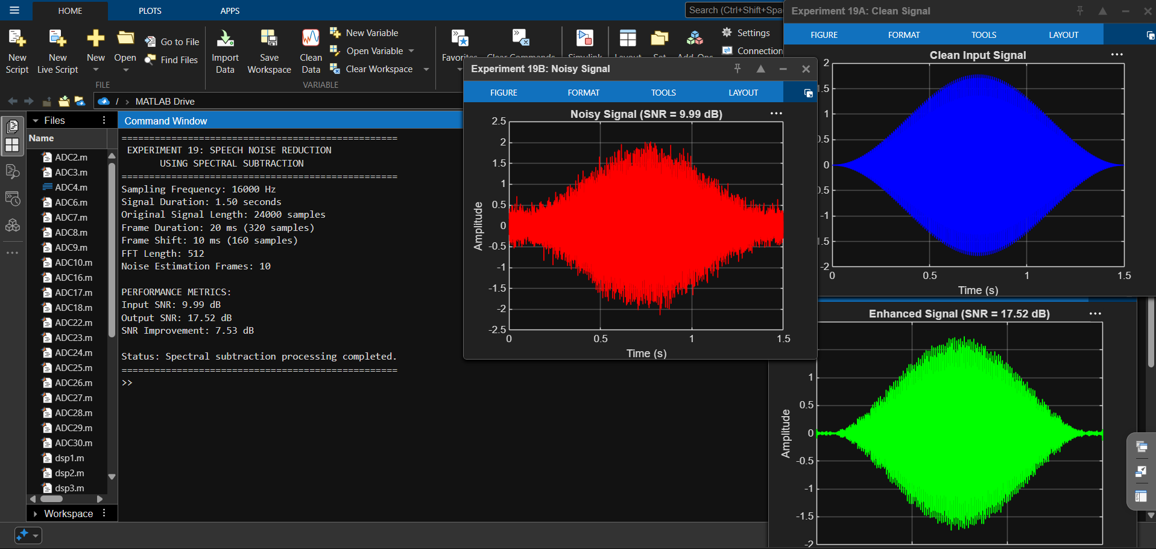
Figure 19.1: MATLAB results and signal waveforms.
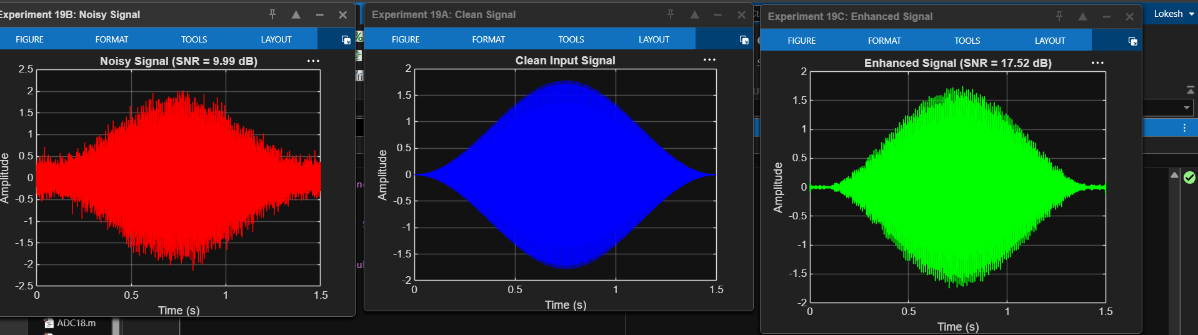
Figure 19.2: Clean, noisy and enhanced signal comparison.

9. DISCUSSION
The noisy waveform contains random fluctuations superimposed on the test signal. Spectral subtraction attenuates components estimated to be associated with noise, while the noisy phase is retained. The inverse FFT and overlap-add reconstruct the enhanced output. In the submitted MATLAB run, the SNR increased from 9.99 dB to 17.52 dB, a reported improvement of 7.53 dB.
The input is a synthetic speech-like multitone signal, not a recording of natural speech. The initial frames used for noise estimation may also contain signal energy. Therefore, the displayed result demonstrates the method on this generated test signal; real-speech performance depends on selecting suitable noise-only frames and on the noise characteristics.

10. PRECAUTIONS
- Use a sampling frequency suitable for all signal components.
- Ensure each selected frame contains the required number of samples.
- Choose appropriate frame overlap and windowing to reduce frame-boundary artifacts.
- Select noise-estimation frames carefully because speech-containing frames can bias the estimate.
- Do not interpret a synthetic test signal as a real speech recording.

11. CONCLUSION
Spectral subtraction for noise reduction was implemented in MATLAB using frame-based FFT processing, noise-spectrum estimation, magnitude subtraction, inverse FFT and overlap-add reconstruction. In the displayed simulation, the input SNR was 9.99 dB and the output SNR was 17.52 dB, giving a reported improvement of 7.53 dB. The experiment demonstrates spectral subtraction for noise reduction in a generated test signal.

